**Tasks To Be Performed:**

1. Add 2 nodes to Jenkins master

2. Create 2 jobs with the following jobs:

a. Push to test

b. Push to prod

3. Once a push is made to test branch, copy Git files to test server

4. Once a push is made to master branch, copy Git files to prod server

* Created 3 instance as Jenkins(Master), Node1 and Node2

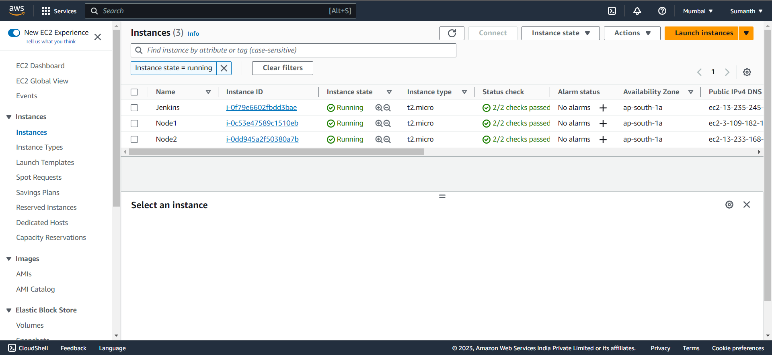

* Installed Java and Jenkins in my Master node and logged in to the Jenkins and added my Node1 and Node2 to my Jenkins Master

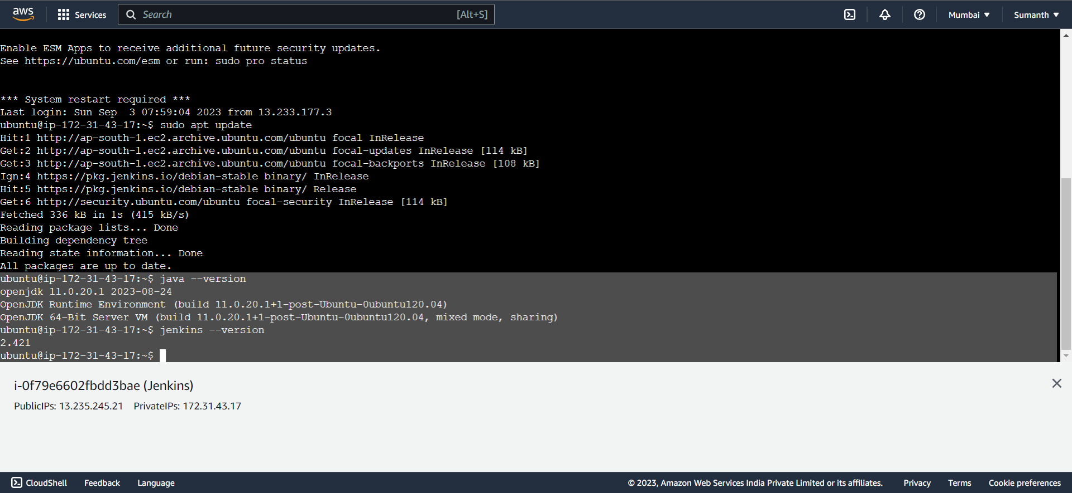

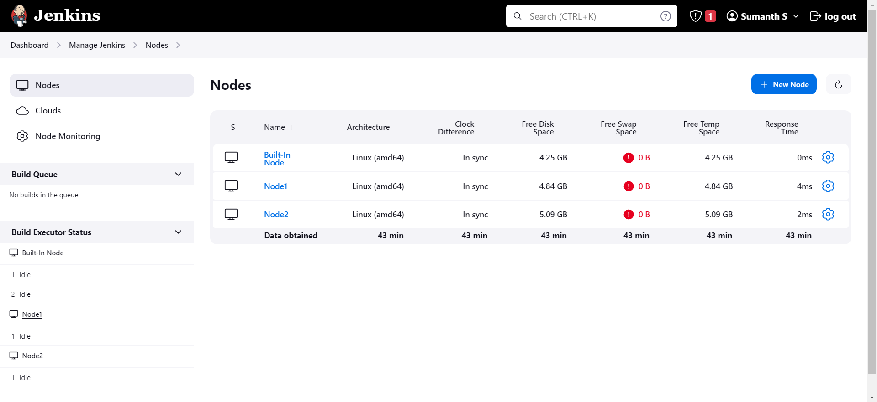

* Created two jobs with the name Prod and Test

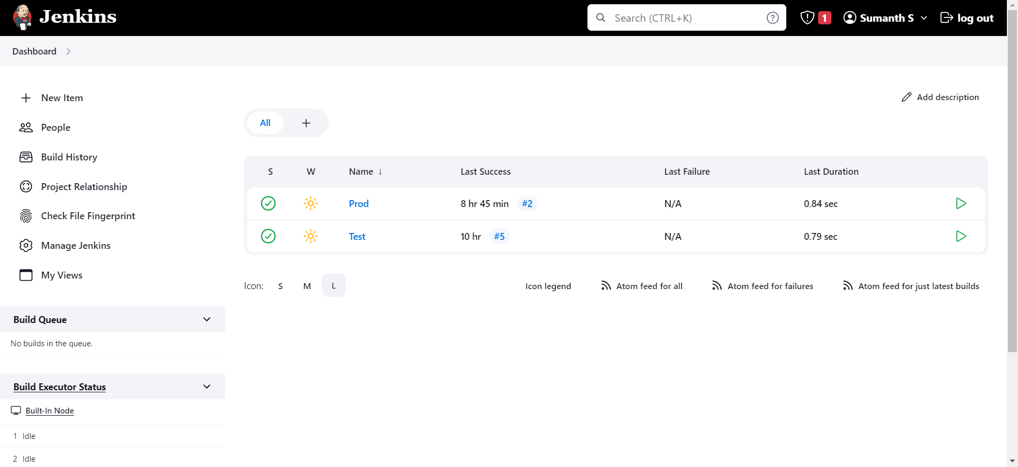

* Created webhook for implementing the new pipeline once the push has been made

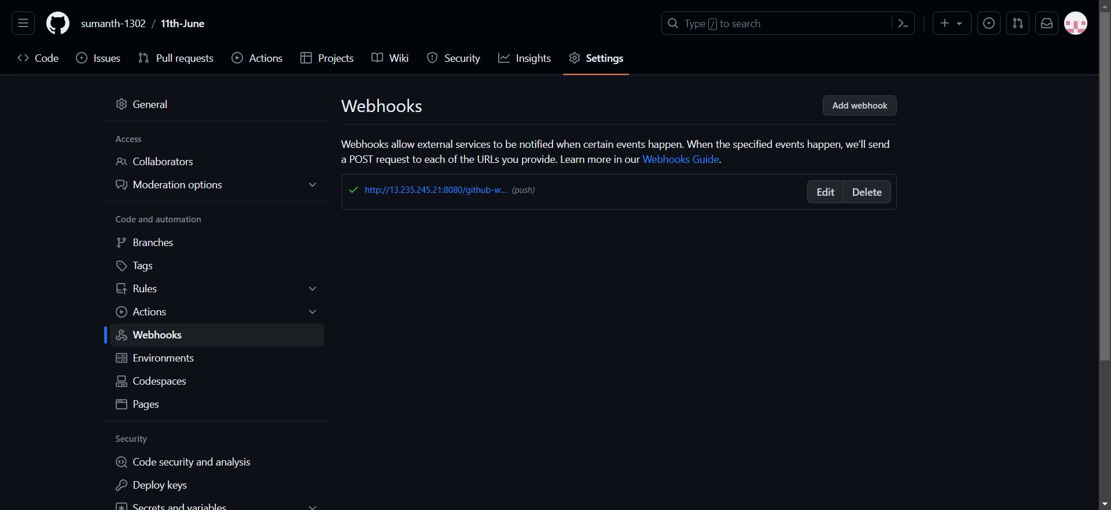

* After push is made to develop branch, copied git files to test server

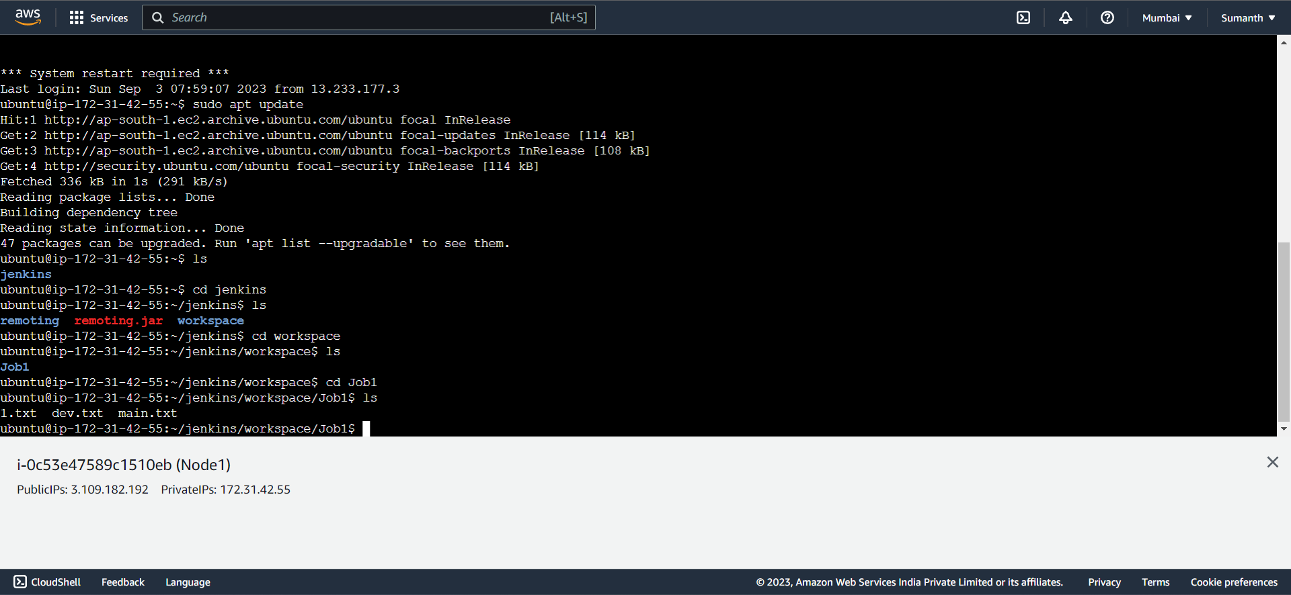

* After push is made to develop branch, copied git files to prod server

